

Hay Communications Co-operative

Zurich Location - 72863 Blind Line | 519-236-4333

Exeter Location – 168 Thames Rd, W | 519-235-3369

Good Afternoon.

There are exciting changes coming to TV service offered by Hay Communications – a new delivery system. But that’s not why we are contacting you today. Currently we have customers on four different package line-ups that we have offered over the years. It’s time to get all our customers on the same line-up before we make the switch to our new streaming type service.

The **BASIC package** you are on was our very first service line-up from way back in 2010. **On August 1st you will be moved to our Select TV Package**. Your monthly fee will remain the same. I have outlined below the exact changes to your service, but rest assured you will be gaining some great channels and hopefully not losing any you really love. However, there are some options there as well.

|  |  |  |
| --- | --- | --- |
| **Channels you will LOSE** | **Channel #** | **Available in a Theme or Stand Alone (SA)** |
| APTN | #18 | Inform Theme $8/mo |
| BBC World | #67 | Inform Theme $8/mo, & SA $5/mo |
| CMT | #180 | Entertain Theme $8/mo & SA $5/mo |
| CNN | #63 | Inform Theme $8/mo & SA $8/mo |
| DTOUR | #339 | Top Picks 1 Theme $8/mo & SA $5/mo |
| HLN | #62 | Inform Theme $8/mo & SA $5/mo |
| MTV | #186 | Entertain Theme $8/mo & SA $5/mo |
| MUCH | #191 | Entertain Theme $8/mo & SA $5/mo |
| NFL Network | #472 | Pass Time Sports Theme $12/mo |
| Stingray Music | #900’s | Entertain Theme $8/mo (conditions apply for businesses) |

|  |  |  |
| --- | --- | --- |
| **Channels you will GAIN** | **Channel #** | **Extras that come with the channel** |
| CTV Drama | #246 | Stream under the CTV app (Channels to Go) |
| Discovery Channel | #381 |  |
| HGTV | #360 | Stream under the Global app (Channels to Go) |
| Peachtree | #241 |  |
| Showcase | #520 | Stream under the Global app (Channels to Go) |

*ALL of these Channels are available in the Complete TV Package for $60/mo  
To find details on our channel line-up go to www.hay.net/television*

I have included a channel number card that shows our current channel line-up and the channels you will have in the **Select TV Package**. Any additional theme packages or standalone channels you may be subscribed will remain on your account. If you would like to add any of the listed channels or themes above, please call us at

519-236-4333 or 519-235-3369. We truly apologize for creating this disruption in your TV service and hope you enjoy the new channels in the Select Package. We will be in touch shortly about the NEW Hay Xstream TV service.

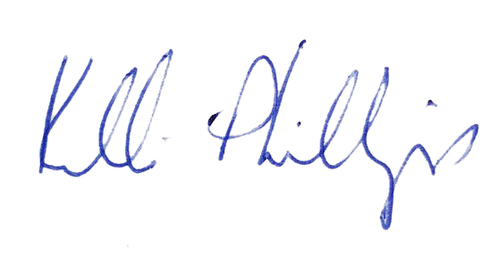 Yours truly,

Kelli Phillips, Marketing Director